Intensity Level Resolution
Code:
import cv2
import numpy as np
image = cv2.imread('elma.jpg', cv2.IMREAD_GRAYSCALE)
print(f"Veri tipi: {image.dtype}")
print(f"Min yoğunluk: {np.min(image)}")
print(f"Max yoğunluk: {np.max(image)}")
normalized_image = cv2.normalize(image, None, 0, 255, cv2.NORM_MINMAX)
normalized_image = np.uint8(normalized_image)
cv2.imshow('Normalize Edilmiş Görüntü', normalized_image)
image_16bit = np.uint16(image) * 256
# Yeni 16-bit görüntü aralığını kontrol et
print(f"16-bit görüntü - Min yoğunluk: {np.min(image_16bit)} Max yoğunluk: {np.max(image_16bit)}")
normalized_16bit_image = cv2.normalize(image_16bit, None, 0, 255, cv2.NORM_MINMAX)
normalized_16bit_image = np.uint8(normalized_16bit_image)
cv2.imshow('16-bit Normalize Edilmiş Görüntü', normalized_16bit_image)
cv2.waitKey(0)
cv2.destroyAllWindows()

Code Explanation:
The following code demonstrates how to manipulate and visualize intensity levels in an image (elma.jpg) at different bit depths using OpenCV. The focus is on converting the image between 8-bit and 16-bit depths, normalizing intensity levels, and visualizing the results.
1. Loading the Image
The image elma.jpg is loaded in grayscale mode with the command:
image = cv2.imread('elma.jpg', cv2.IMREAD_GRAYSCALE)
Grayscale images represent pixel intensity values from 0 (black) to 255 (white) in an 8-bit format.
2. Checking Image Intensity Range
After loading the image, the data type and intensity range of the pixels are printed to understand the image's bit-depth and intensity distribution:

print(f"Data type: {image.dtype}")
print(f"Min intensity: {np.min(image)}")
print(f"Max intensity: {np.max(image)}")
These values give insights into the image's resolution and how the pixel intensities are distributed.
3. Normalizing Image to 8-bit
The image is normalized using OpenCV’s cv2.normalize function:
normalized_image = cv2.normalize(image, None, 0, 255, cv2.NORM_MINMAX)
This step ensures that the pixel intensity values are scaled to the full 8-bit range (0 to 255). The cv2.NORM_MINMAX flag maps the pixel values linearly between the image’s minimum and maximum intensity.
4. Converting 8-bit Image to 16-bit
The 8-bit image is converted into a 16-bit image by scaling its pixel values:
image_16bit = np.uint16(normalized_image) * 256
This increases the intensity resolution by multiplying each pixel value by 256. The pixel intensity range is expanded from 0-255 (8-bit) to 0-65535 (16-bit).
5. Normalizing the 16-bit Image
The 16-bit image is normalized to fit the 8-bit range (0-255) for display:
normalized_16bit_image = cv2.normalize(image_16bit, None, 0, 255, cv2.NORM_MINMAX)
normalized_16bit_image = np.uint8(normalized_16bit_image)
This normalization ensures the 16-bit image can be properly displayed within the constraints of an 8-bit screen, making it easier to visualize.
6. Displaying the Results
Finally, two images are displayed using the cv2.imshow function:
- The normalized 8-bit image is displayed.
- The 16-bit image normalized back to 8-bit is also shown.
The program waits for a key press before closing the windows:
cv2.waitKey(0)
cv2.destroyAllWindows()
output:
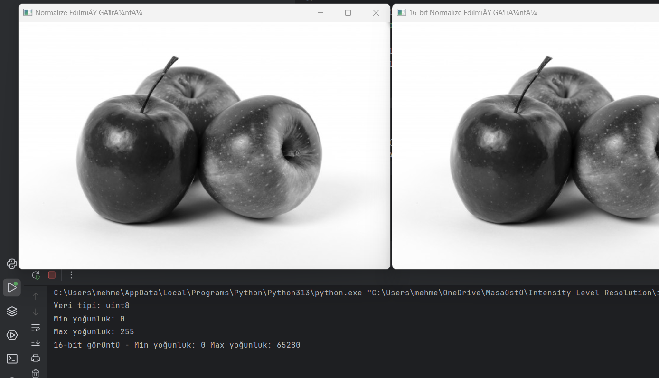

Report
Code Working Logic:
- Image Loading: The grayscale image is loaded into memory using cv2.imread in grayscale mode. This ensures the image will have pixel values ranging from 0 to 255, representing varying levels of intensity (from black to white).
- Range Checking: The program checks the intensity range by printing the data type of the image and the minimum and maximum intensity values. This helps in understanding the intensity resolution of the image.
- Normalization to 8-bit: The image is normalized to the full 8-bit range (0-255). This ensures that the minimum and maximum pixel values in the image are mapped to the full intensity spectrum of an 8-bit image.
- 16-bit Conversion: After normalizing the 8-bit image, the intensity values are scaled to increase the bit depth from 8-bit to 16-bit. This step enhances the resolution of intensity values, allowing for finer distinctions between pixels.
- 16-bit Normalization: The 16-bit image is normalized back to the 8-bit range for visualization purposes. This step ensures that the enhanced 16-bit intensity levels can be viewed within the limits of standard image display hardware.
- Display: The processed images are displayed in separate windows. One shows the normalized 8-bit image, and the other shows the 16-bit image converted back to 8-bit for visualization.

